Lab 02 Applications of propositional logic (Solution)
Objective
Solving exercises from the textbook in chapter 1.2-1.3

Current Lab Learning Outcomes (LLO)
By completion of the lab, the students should be able to:

understand the truth values of the compound propositions, negating the compound proposition
Lab Requirements
Students allowed using their lecture notes in the lab in order to solve the exercises.

Lab Assessment
1- Divide students to groups and let them to solve the given example.
2- Discuss the answers with the groups and write on board the optimal solution.
Lab Description

- Translate the given statement into propositional logic using the propositions provided
You cannot edit a protected Wikipedia entry unless you are an administrator. Express your answer in terms of e:“You can edit a protected Wikipedia entry” and a: “You are an administrator

e → a or ￢a → ￢e (p → q is q unless ￢p )

- Express these system specifications using the propositions p “The message is scanned for viruses” and q “The message was sent from an unknown system” together with logical connectives (including negations).
a) “The message is scanned for viruses whenever the message was sent from an unknown system.”
b) “The message was sent from an unknown system but it was not scanned for viruses.”
c) “It is necessary to scan the message for viruses whenever it was sent from an unknown system.”
d) “When a message is not sent from an unknown system it is not scanned for viruses.”

a) q →p b) q ^￢p c) q →p d) ￢q →￢p

- Determine whether each of these conditional statements is true or false.
a) If 1 + 1 = 2, then 2 + 2 = 5.
b) If 1 + 1 = 3, then 2 + 2 = 4.
c) If 1 + 1 = 3, then 2 + 2 = 5.
d) If monkeys can fly, then 1 + 1 = 3.
a) False b) True c) True d) True

- State the converse, contrapositive, and inverse of each of these conditional statements.
a) If it snows tonight, then I will stay at home.
b) I go to the beach whenever it is a sunny summer day.
c) When I stay up late, it is necessary that I sleep until noon.

a) Converse: If I stay home, then it will snow tonight. Contrapositive: If I do not stay at home, then it will not snow tonight. Inverse: If it does not snow tonight, then I will not stay home.
b) Converse: Whenever I go to the beach, it is a sunny summer day. Contrapositive: Whenever I do not go to the beach, it is not a sunny summer day. Inverse: Whenever it is not a sunny day, I do not go to the beach.
c) Converse: If I sleep until noon, then I stayed up late. Contrapositive: If I do not sleep until noon, then I did not stay up late. Inverse: If I don’t stay up late, then I don’t sleep until noon.

- Show that (p → r) ∧ (q → r) and (p ∨ q) → r are logically equivalent using truth table.
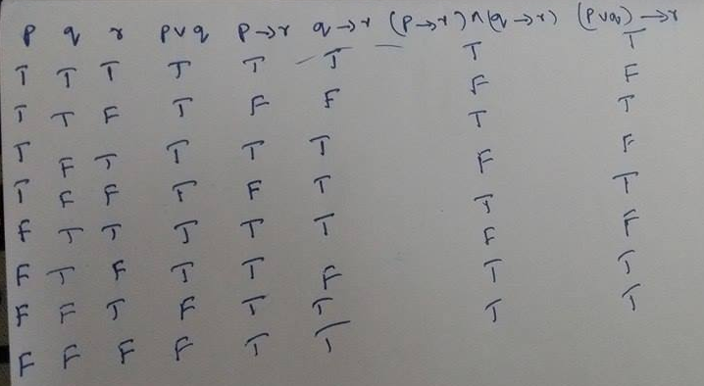

- Show that (p → r) ∨ (q → r) and (p ∧ q) → r are logically equivalent using truth table
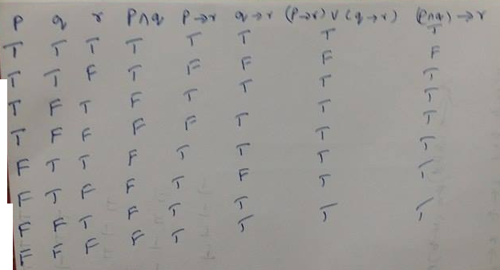
- Show that (p → q) ∧ (q → r) → (p → r) is a tautology using truth table

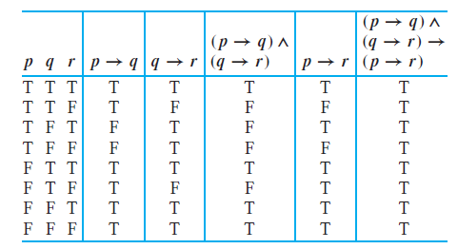

- Use De Morgan’s laws to find the negation of each of the following statements.
a) Jan is rich and happy.
b) Carlos will bicycle or run tomorrow.
c) ”If elephants can fly, then the Cubs will lose the World Series this year”
d) if I am not hungry then it is not noon

Solution: a) Jan is not rich, or Jan is not happy. b) Carlos will not bicycle tomorrow, and Carlos will not run tomorrow. c) elephants can fly and the cubs will not lose the World Series this year. d) : I am not hungry and it is noon

- Determine whether the compound propositions are satisfiable.
a) (p ∨￢q) ∧ (￢p ∨ q) ∧ (￢p ∨￢q)
b) (p → q) ∧ (p →￢q) ∧ (￢p → q) ∧ (￢p →￢q)
c) (p ↔ q) ∧ (￢p ↔ q)
Solution: A proposition is satisfiable if some setting of the variables makes the proposition
True or atleast one combination of the rows must be true. If we write the truth table for the above proposition

a)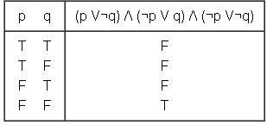
satisfiable
b)
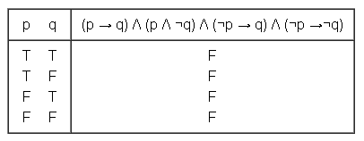
Not satisfiable
c) 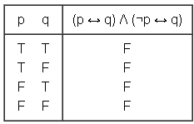
Not Satisfiable

